**Deployment Document**

Dokmee Custom Application

1. **Technology requirements**

* Install Microsoft SQL Server
* Install Internet Information Services (IIS)

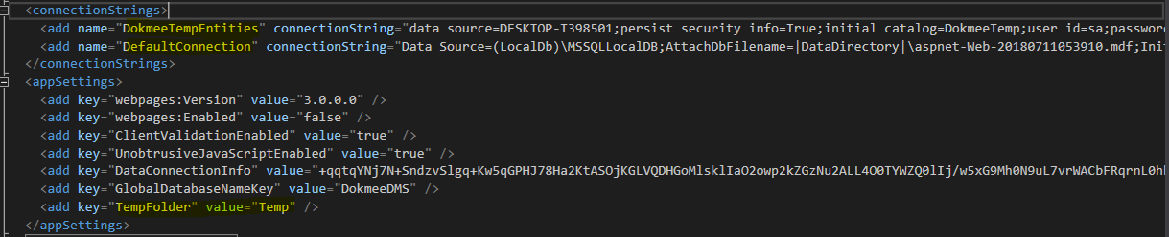

1. **Create the web application in IIS**

* After create the deployment files. Go to the IIS (Internet Information Services) to create the web application

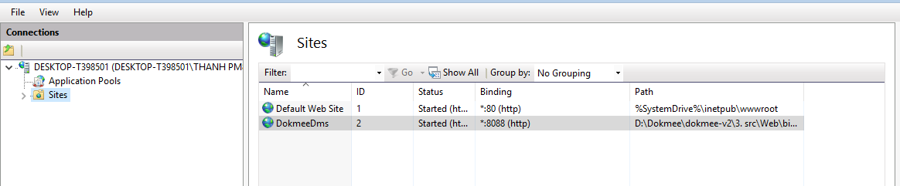

* Right click on the Sites and choose “Add Website” in the menu

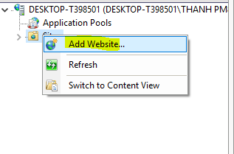

* Add website information:
  + Site Name: the website name in the IIS
  + Physical path: the folder contains the deployment files
  + Port: set the port to access the web app

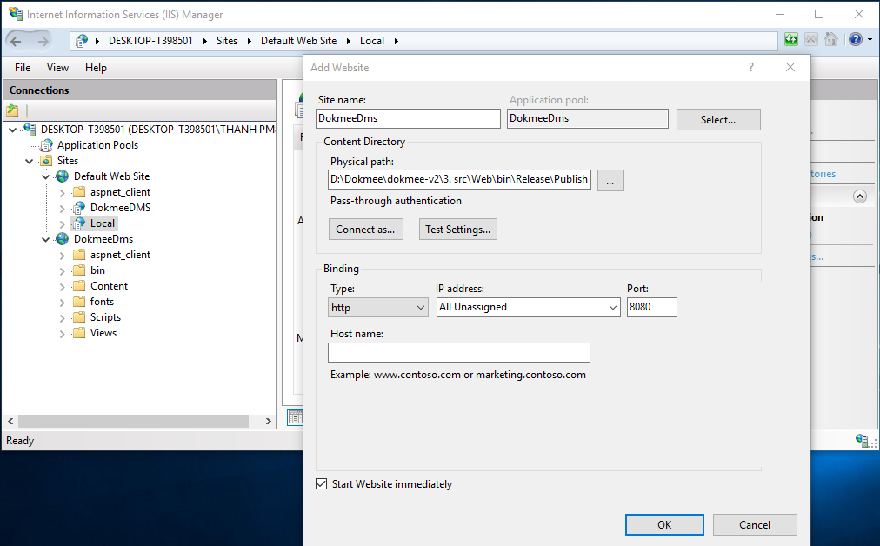

* Setup Login account for IIS:
  + Click on **Connect as…** button
  + When Connect popup open, select **Specific user**, then click button **Set**

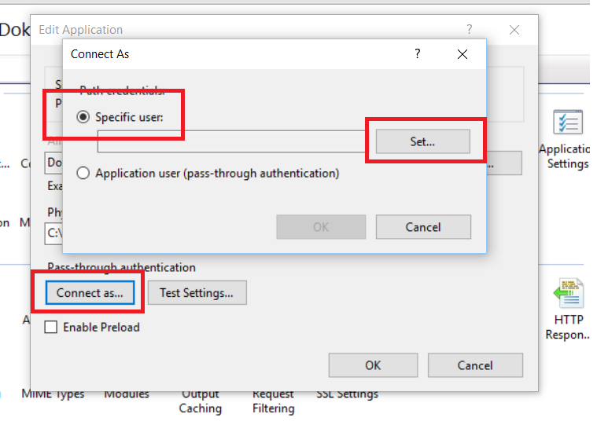

* + When Set Credentials popup open, enter your **windows login account to User name**, **password** and **Confirm password** box. Then click Ok button.

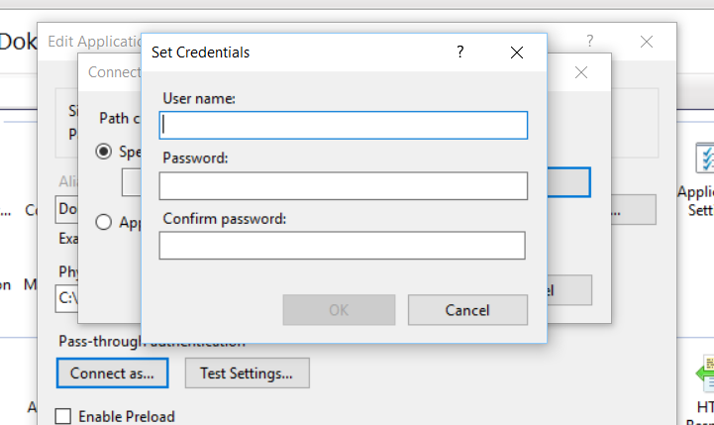

* + Click Ok to save login information
* Testing access right for current user:
  + After input account login success, click on **Test Setting** button and new windows will appear show result access right to deploy folder. If authenticate success, the result will similar below

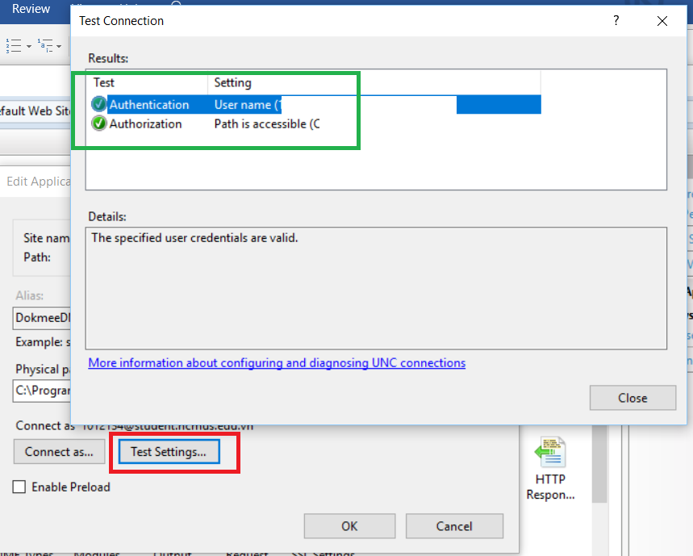

* Can change the settings of the website on:

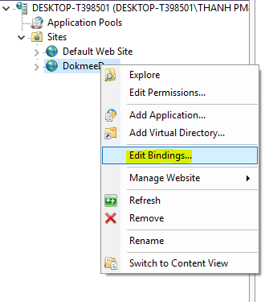

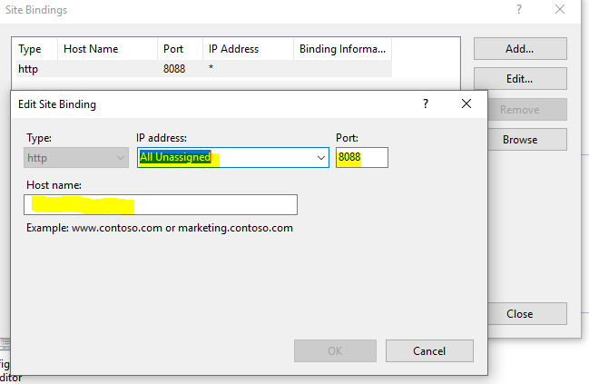

* Browser the website:

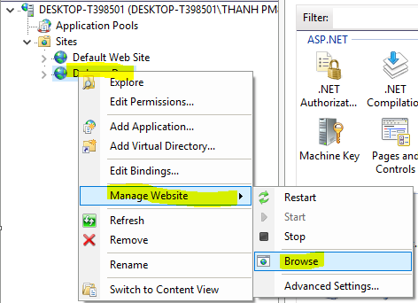

1. **Configuration Application**

After browser the application, the application will navigate to Installation page at the first time, or you can follow the link: **<your-host-name>/install**. If you need any change in configuration, you can access the page again. Page will display:

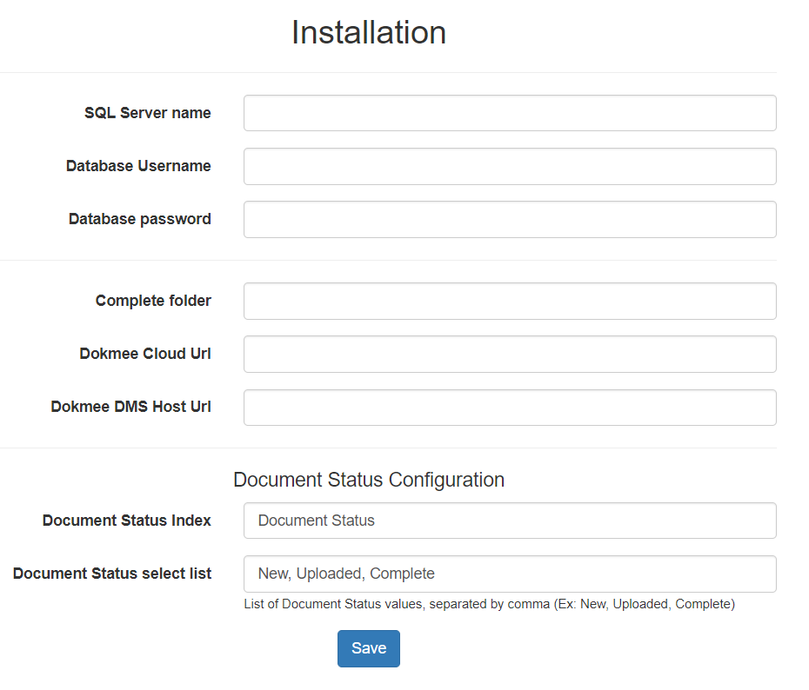

* Input your configurations to value:
  + **SQL Server name:** your database name.
    - Ex: localhost\SQLEXPRESS
  + **Database Username**: your database login account:
    - Ex: sa
  + **Database password**: your database login password.
* Config application
  + **Complete folder**: the folder where document will move to when you click on **Complete** button in search page.
    - Ex: Complete folder
  + **Dokmee Cloud Url**: Url of Dokmee Cloud.
    - **Ex**: http://web.dokmee.com/dokmeedms
  + **Dokmee DMS Host Url**: Your local DMS Url.
    - **Ex**: <http://localhost/DokmeeDMS>
* Config for document status values:
  + **Document Status Index**: Your document status name in DMS cabinet setting.
    - **Ex**:Document Status
  + **Document Status select list**: Your list values of document status config in DMS cabinet setting
    - **Ex**: **New, Uploaded, Complete**

1. **Known installation issues:**

This section you can find some common problems and solutions when deploy application.

* 1. A network-related or instance-specific error occurred while establishing a connection to SQL Server. The server was not found or was not accessible. Verify that the instance name is correct, and that SQL Server is configured to allow remote connections. (provider: SQL Network Interfaces, error: 26 - Error Locating Server/Instance Specified)

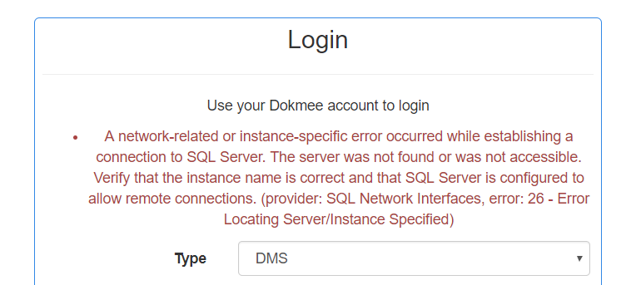

* Problem: **SQL Server name** setting is not correct
* Solution: Please go to **/install** and check **SQL Server name** is correct
  1. 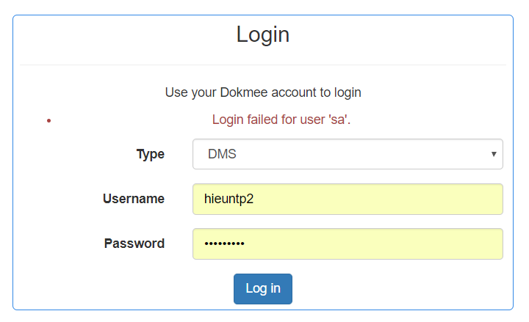Login failed for user '***'.
* Problem: Username, password for login database is not correct.
* Solution: Please go to **/install** and check **Database Username/ Database password** is correct.
  1. Access to the path “<deploy-address>/web.config” is denied

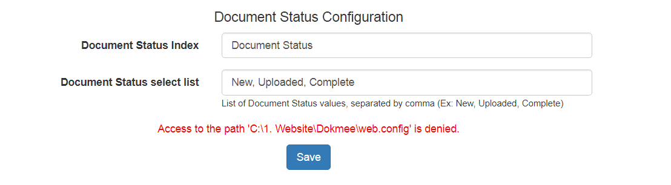

* Problem: There is no access right to write web.config file in deployment folder.
* Solution:
  + Open your deployed folder, Ex: C:\Dokmee
  + Right click your deployed folder, and select **Properties**
  + When Properties folder open, open Security Tab. Make sure current login user have **Full Permission** and **Modify permission**. If there are no access right for 2 permission, please click Edit and set 2 permissions for current login user.

